bxrf]s O{nfsfsf] P]ltxfl;s tyf wfld{s dxTj
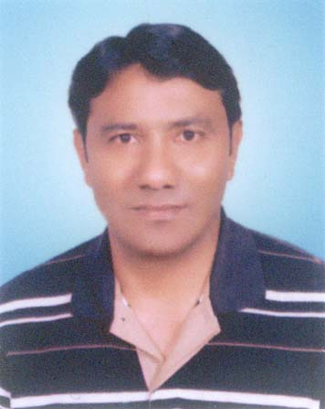
-k|]dl;+x a:Goft
M.A.History
M.Sc.Global Security, UK.
Ph.D. Military History

bxrf]ssf] P]ltxfl;s dxTj

1= k/fk'j{ sfnb]lv g} uf]/vf / g"jfsf]^ O{nfsfsf dflg;x? dsjfgk"/ eP/ lxGb":tfg hfg" kbf{ bxrf]s rGbflu/L-lrTnfª x"b} hfGy] . olx af^f] lx*\bf rGbflu/Lsf] *f*f]af^ >L 5 j*f dxf/fhflw/fh k[YjLgf/fo)f zfxn] klxnf] k^s sf&df)*F} pkTosf b]v]/ df};"kmsf] dgdf sf&df)*f} pkTosfsf] tLg} zx/sf] /fhf x"g] O{R%f hfu]sf] lyof] . 1801 ;fndf g]kfn Plss/)f z"? ePkl% 1803 ;fn leq gfNb"d-dxfb]j kf]v/L -xfnsf] gu/sf]^_ O{nfsf ;d]t sAhf eof] . To;kl%sf] lbgx?df ePsf ;Dk")f{ Plss/)f cleofg h:t} M dsjfgk"/, l;Gw"nL, sLlt{k"/ / sf&df)*F} ;Ddsf] Plss/)f o"$x?sf] ;fy} 1819 df dsjfgk"/ u(Ldf ePsf] dL/sf;Ld / 1824 df l;Gw"nLsf] kf}jfu(Ldf ePsf] SofK^]g lsGns lj?$sf] o"$x? ;d]t oxL bxrf]saf^ ;+rfng ePs]f lyof] . bxrf]s >L 5 k[YjLgf/fo)f zfxsf] cltg} dg u/]sf] / c#f]lift /fh k|f;fb g} lyof] . ha 1825 sf] O{Gb|hfqfsf] dWo/ftL sflGtk"/ ljho eof], To;kl% uf]/vfnLx?sf] ;a} sf/jfxL xg"dfg(f]sf b/af/af^ x"g yfNof] . o;/L 1803 b]lv 1825 ;fn;Dd, 22 aif{ oxL bxrf]s O{nfsfdf a;]/ >L 5 k[YjLgf/fo)f zfxn] /fhsfh / g]kfn Plss/)f cleofg rnfO{aS;]sf] lyof] . ;}lgs zAbfjnLdf eGg" kbf{ bxrf]s g]kfn Plss/)fsf] ;}lgs x]*Sjf^/ tyf Pp^f alnof] Firm Base lyof] .

2= sLlt{k"/sf] klxnf] o"$df sfhL sfn" kf+*] dfl/Pkl% >L 5 k[YjLgf/fo)f zfxsf] x"s"d adf]lhd jxf+sf] zjnfO{ uf]/vf k"¥ofpg ^f(f ePsf]n] uf]/vf gnuL bxrf]saf^} sfn" kf+*]sf] #/ b]lvg] u/L jxf+sf] #/tkm{ rLtf kmsf{O{ o;} :yfgdf sfn" kf+*]sf] bfx ;+:sf/ ePsf] lyof] . g]kfn Plss/)f cleofg, >L 5 k[YjLgf/fo)f zfx, zfxL g]kfnL ;]gf / g]kfnsf] ;}lgs O{ltxf;df bxrf]ssf] dxTj Hofb} pRr x"g" kg{] b]lvG% . t/ xfn;Dd klg g]kfnsf] O{ltxf;df o; If]qsf] cWoog cg";Gwfg gx"g"df P]ltxfl;s If]qdf &"nf] #f^f x"g k"u]sf] ;d]t dxz"; ul/G% .

ef}uf]lns agfj^

3= sf&df)*f} pkTosfsf] klZrdL kf^f]df /x]sf] of] cUnf] *f+*f]n] rf/}lt/ lgoGq)F -Domination_ u%{ eg] ;]gfx?sf] nflu of] Ground of Tactical Importance sf] hldg xf] . O{Gb| bx / o;sf] wfld{s dxTjn] ubf{ of] If]q ;fdflhs kIfaf^ klg ;Ddflgt % . o; If]qsf] ;a}eGbf cUnf] *f+*f] O{Gb| bxsf] ^fj/ O{nfsf xf] . h"g &f+paf^ >L 5 k[YjLgf/fo)f zfxsf] d"Vofno lyof] eg] Tof] eGbf sl/a 2=5 ls=dL= tn / k"j{ tkm{sf] csf{] *f+*f] ^"Kkfdf j*fdxf/fhflw/fh k[YjL gf/fo)f zfxsf] kfnfdf ag]sf] c? lsNnfx? -forward Defended Locatities _ sf]t#/x? tyf ljGWofjfl;gL dlGb/ klg lyof] . h"g P]n] klg eUgfj]zsf] ?kdf kfO{G% . ;dfh;]jLx?jf^ dftf ljGWofjfl;gLsf] dlGb/ k'g{lgdf)f{ ul/g] sfd x"g nfu]sf] j'lemPsf]n] bxrf]ssf] ljl;{Psf] Oltxf; vf]tlng] % eGg] cfzf lng ;lsG% . jf}$ u"Djfx?n] (fSg nfu]sf] of] kj{tLo >[vnfdf lxGb"wd{sf] k|lts dftf ljGWofjfl;gLsf] dlGb/ :yfkgf ul/Pdf ;"gdf ;"uGw ylkg] % . O{Gb|bx O{nfsf eGbf of] :yfg xf]rf] % eg] a"^\ofg -?v_ x?n] (flsPsf] % .o; :yfgdf /x]sf dxTjk')f{ kIf lgDg %g\ M
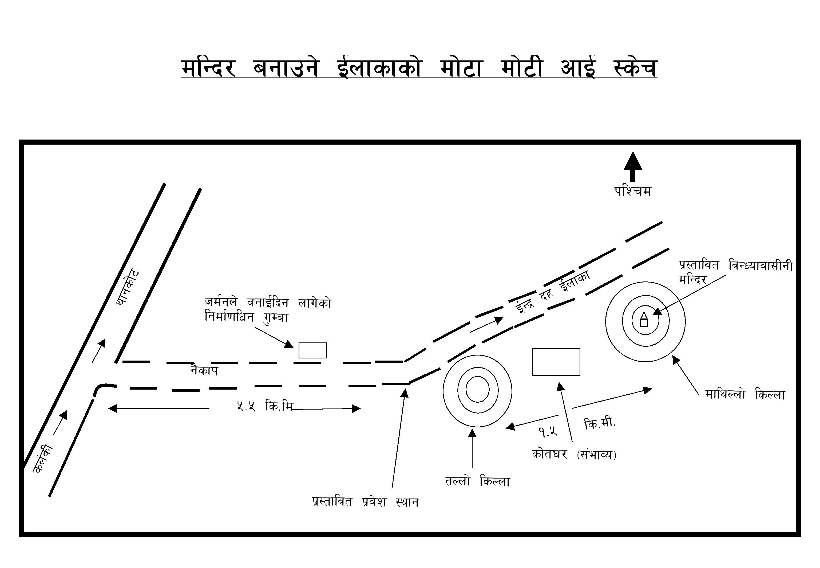

4= -s_ tNnf] lsNnf of] dlGb/ lgdf{)f :ynsf] Entry point af^ sl/a 400 uhsf] klZrd psfnf]df % . dl^nf] hldgdf Trech sf] ?kaf^ uf]nfsf/df vlgPsf] % . Inner / Outer #]/f lbP/ agfO{Psf] of] lsNnfdf ("éfsf] k|of]u ePsf] b]lv+b}g eg] eTs]/ xfn Kneeling position ;Ddsf] ulx/fO{ /xsf]% . xfnsf] lx;fjdf Pp^f Platoon nfO{ hUuf lng k"Ug] Ifdtf b]lvG% .

-v_ eTs]sf] #/ tNnf] lsNnfaf^ sl/a 300 uh klZrd psfnf]df ;fgf] / eTs]sf] #/sf] cjz]if h:tf] b]lvG% . ;Dejt of] Castle -lsNnf_ sf] ?kdf agfO{Psf] sf]t#/ x"g ;Sb% . ;fy} of] sdf)*/ j:g] sdf)* kf]i^ klg x'g ;Sb% .

-u_ dflyNnf] lsNnf / k|:tfljt dlGb/ O{nfsf of] tNnf] lsNnf eGbf &"nf] % eg] agfj^ tNnf] lsNnf h:t} Inner / Outer Circle df Round Shape df agfO{Psf] % . dl^nf] hldgdf agfO{Psf] of] lsNnfdf klg ("éfsf] k|of]u gePsf] / xfn 2 j^f platoon kmf}hn] hUuf lng ;Sg] b]lvG% . oxL lsNnfsf] lelq l(:sf]df ("+ufx? y"k|]/ a;]sf]% . ;fob lsNnf vGbf lg:s]sf ("+ufx? oxf+ /flvPsf x"g ;Sb% . h;nfO{ To;a]nfsf] ;}Gox?n] agb]jLsf] ?kdf k"hf ug{] u/]sf] eGg] a"lemG% . o;} :yfgdf xfn ljGWofjfl;gLsf] dlGb/ agfpg nfluPsf] j"lemG% . of] :yfg o; Spour sf] ;a}eGbf cUnf] Spot xf] .

5= >L 5 k[YjL gf/fo)f zfxn] k|of]u ul/aS;]sf] #/, sf]t#/, hd/f #/, ;}lgs d"Vofno tyf Main defensive position x? O{Gb|bx O{nfsfdf ePsf] / h"g xfn dlGb/ agfpg nfusf] O{nfsfaf^ e]l^Psf lsNnfx? Main defensive position nfO{ depth lbg Outer Posts sf] ?kdf agfO{Psf Round circle sf ^«]Grx? x"g . vf;} lsNnf eg] xf]O{gg . o; k|sf/sf Trench x? gu/sf]^, w"lnv]n, lzjk"/L / sfe|]knfGrf]ssf] gja"$ O{nfsfdf k|;:t kfO{G%g\ . h;nfO{ >L 5 sf] ;/sf/ k"/ftTj ljefun] lsNnfsf] ?kdf ;dfj]z gu/]sf] a"lemG% . pQm a"+bfx?nfO{ dgg u/L o; O{nfsfsf] P]ltxf+l;s,wfld{s tyf ko{^lso ljsf;sf] nflu lgDg pkfo clu j(fpg ;'emfj /flvPsf] % M

-s_ xfn e}/x]sf] sRrf df]^/ af^f]af^ dlGb/ agfpg] O{nfsf sl/a 800 ld^/ dfq ePsf] / Ridge Line sf] aLr aLrdf v"nf rf}/ ePsf]n] ?v lj?jf / cGo k|fs[lts kIfsf] vf;} Ifo gx"g] b]lvG% .

-v_ pQm Ridge Line df /x]sf ?vx? ;"hftsf ge} u"/f+;, sfkmn, sf+*f h:tf xf]rf / a"^\ofg vfnsf ePsfn] ;f] sf^\bf cfly{s ?kdf ;d]t vf;} #f^f gx"g] b]lvG% .

-u_ bfof+ jf afof+ tkm{af^ pQm af^f] gagfp+bf / cGo lgdf{)f sfo{ ubf{ ;d]t tNnf] lsNnf, eTs]sf] #/ / dflyNnf] lsNnfnfO{ s]xL c;/ gkg{] x"bf+ xfn e}/x]sf] pQm tLg} :yfgdf s]xL afwf gkg{] b]lvG% .

-#_ dflyNnf] lsNnfsf] larf} efudf algg] dlGb/n] klg xfn ePsf] lsNnfnfO{ vf;} c;/ gk"Ug] b]lvG% t/ lsNnfsf] ljrf}+ ljrdf l;(L agfO{ dlGb/df af^f] k"¥ofpg" pko"Qm x"g]% .

-ª_ xfnnfO{ ePsf lsNnf -Round Shape Trench) x?nfO{ lsNnfsf] lhjfGt ?k lbgsf] nflu dlGb/ lgdf{)f ug{] cfof]hs ;ldltn] ;}lgs ;Nnfxsf/sf] Tactical Advice df k"/fg} kf/fn] lsNnfsf] Renovation ug"{ /fd|f] x"g]% . h;af^ of] If]qsf] Military Value cem} a(\g] dxz"; ul/G% .

-r_ k|:tfljt of]hgf cg";f/ oxf+ dlGb/ lgdf{)f ePdf o; If]qsf] cfly{s, wfld{s / ;fdflhs ljsf;d} ^]jf k"Ug] % eg] oxL lg/ xfn hd{gx?sf] ;xof]udf lgs} &"nf] u"Daf klg lgdf{)f e}/x]sf]n] of] If]qdf a"$ wd{sf] ;fy;fy} lxGb" wd{sf] klg dlxdf a(\g] tYo ^*\sf/f] /x]sf] dxz"; ul/G% .

8= of] bxrf]s O{nfsf;+u xfnsf] /fhtGqsf] ljsf;, Military History, a*fdxf/fh k[YjLgf/fo)f zfx, zfxL g]kfnL ;]gf tyf ljBdfg Tactical Importance ;+u ;f/} dxTj /fVb% . >L 5 sf] ;/sf/af^ xfn;Dd o; O{nfsfsf] cWoog cg";Gwfg gePsf] dxz"; ePsf]n] s"g} klg ;+:yfn] o; ;+DjGwdf kxn u/]df >L 5 a*fdxf/fhlw/fh k[YjLgf/fo)f zfx, df};"kmsf] Military Strategy, g]kfn Plss/)Fdf bxrf]ssf] ;}lgs Pj+ wfld{s dxTj tyf efjL lbgx?df ;d]t of] :yfgaf^ sf&df)*F} pkTosfsf] ;"/Iffdf k"Ug] kmfO{bfx?sf] af/]df ljZn]if)f x"g ;Sg] dxz"; ul/G% .

9= cGtdf, a*Fdxf/fhf k[YjLgf/fo)F zfx g"jfsf]^df :juf{/f]x)F x"g" eGbf cuf*L aS;]sf] lbJo pkb]zdf ;d]t df};"kmn] " bxrf]sdf Pp^f b/jf/ agfpg] O{R%f lyof] t/ EofO{g " eGg] dg;fo JoQm u/LaS;]sf] % . a*fdxf/fhflw/fhsf] cGt/ cfTdf b]lv g} >$f hfu]sf] o; :yfgnfO{ lj;{g" x"b}g . of] O{nfsfdf df]^/af^f] k"uL ;s]sf] / xfn xf]^n Joj;fo ug{{]x?n] rsf{] d"No lt/L wdfwd hUuf vl/b ug{ nfu]sf] a"lemPsf]n] ko{^g If]qsf] ljsf; x"g" /fd|f] yfngL dfGg ;lsG% . tyfkL, ko{^lso, ;}lgs tyf wfld{s dxTjaf^ o; :yfgnfO{ hf]ufpg >L 5 sf] ;/sf/jf^ jf cGo pT;'s ;fdflhs ;+# ;:yfx? dfkm{t kxn sbdL x"g" lgtfGt h?/L ePsf] dxz'; ;d]t ul/G% .

k'gZr M cfjZolso efiffsf] ;"lb\ws/)F ;lxt HRS SHANTI RAJYA LUXMI DEVI SINGH BAJHANGI RARA KUMAR DEEPAK JUNG BAHADUR SINGH MEMORIAL TRUST af^ k|sfzg ul/g] klqsfdf of] n]v k|sfzg ug{ d]/f] dGh"/L % .

- n]vs

